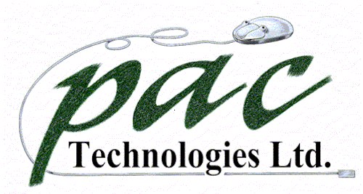
SteelPac Lite
Product Specification Summary

Product Overview

SteelPac Lite has been developed in conjunction with SteelPac V2.0 to offer an EDI solution for the complete supply chain.

Contractors are able to use the SteelPac Lite application to electronically receive, review, manage and electronically forward to the Steel Fabricator reinforcement bar schedules created by any of the various design software packages currently being used by consulting engineers.

SteelPac Lite and SteelPac v2.0 offer a modern and cost effective solution that will enable the industry to begin trading electronically.

SteelPac Lite has been designed to give the contractor a tool that will offer remarkable savings on the purchase and ordering of reinforcement.

SteelPac Lite is written using “State of the art” technologies and is capable of dealing effectively with BS4466 as well as the new BS8666

Key Business Benefits

Immediate contract visibility will give the contractor weight, number of bars and shape code information.

The ability to receive electronically from design, call off drawings or parts of a drawing and electronically send to the Steel Fabricator, reduces massive amounts of manual process and therefore avoids costly mistakes and delays.
Contact:

Lord’s Clough Farm, Kettleshulme, High Peak, SK23 7EH
Tel: 01663 719700 Fax: 01663 732710
Registered in England, No.3479128. VAT No. 707 9510 28
PAC@PACTECH.CO.UK
www.pactech.co.uk
SteelPac v2.0

Product Overview

SteelPac is the first reinforcement program to have the capability to electronically receive reinforcement bar schedules created by any of the various design software packages currently being used by consulting engineers and design consultants. Bar schedules can also be keyed and managed with extreme proficiency. Following on from receiving schedules SteelPac has comprehensive pricing and contract management capabilities, offering the ability to ascertain in seconds the exact stage of a total contract ranging from tendered through works orders to invoicing.

SteelPac has the ability to produce a graphical shape analysis for new contracts helping immensely in obtaining an instant overview of the complexity of the contract. SteelPac is written using “State of the art” technologies and is capable of dealing effectively with BS4466 as well as the new BS8666
Key Business Benefits

We are confident, that within the Reinforcement Industry, SteelPac cannot fail to give your business a competitive edge. The ability to import and export schedule data will show major savings in labour costs immediately. Schedules can be input in seconds rather than days or in some cases weeks.
Quotations can also be turned round electronically in seconds with the knowledge that the contract breakdown and pricing functionality has given the user sufficient information to price the job effectively.

SteelPac can export contracts, or parts of contracts, in seconds. This will enable you to make use of your steel stocks more effectively and unused capacity in other factories within your group.
Product Specification Summary
Contact:

Lord’s Clough Farm, Kettleshulme, High Peak, SK23 7EH
Tel: 01663 719700 Fax: 01663 732710
Registered in England, No.3479128. VAT No. 707 9510 28
PAC@PACTECH.CO.UK
www.pactech.co.uk

